# Running the test code

To run test code for the horiba_ccd_interface class:

1. Download and install Anaconda3 (<https://www.anaconda.com/products/distribution>)
2. Open the “Anaconda command prompt”
3. Create a new python environment named “py38” by running the following command
   1. conda create -n py38 python=3.8
4. Activate the new environment with the command:
   1. conda activate py38
5. Install some python packages with the commands
   1. conda install numpy
   2. conda install matplotlib
   3. pip install pywin32
6. Run the test code for the horiba_ccd_interface class:
   1. python horiba_ccd_interface.py

# Example output of test code

**Reading the full image of the CCD chip:**

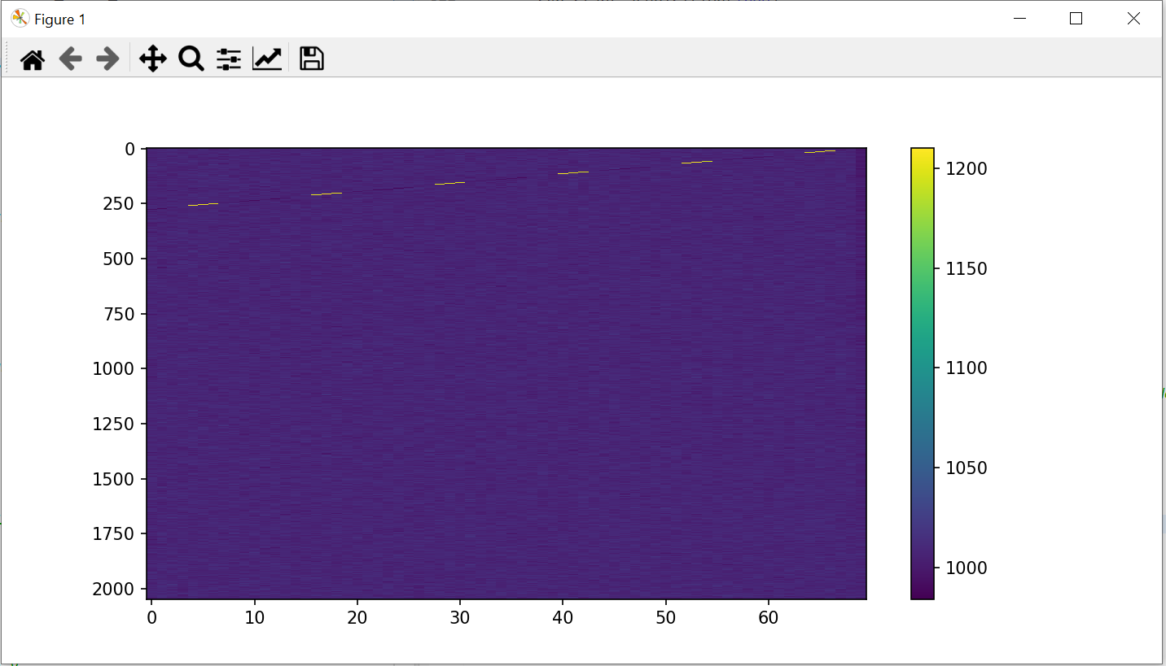

**Reading a spectrum (full binning in y-direction)**

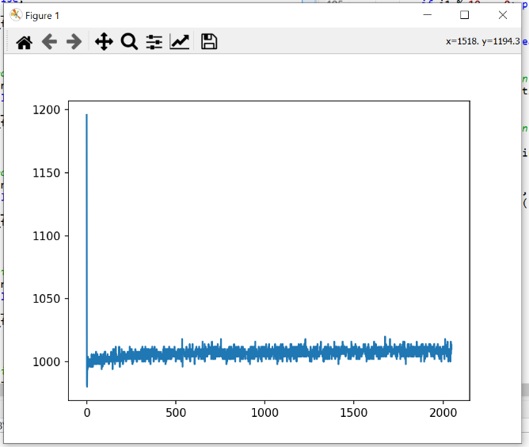**Typical STDOUT output**

Loading the Synergy CCD Interface

Loading CCDs from the Horiba config browser

Found the follwoing CCDs: (CCD1, Syncerity), (CCD2, Syncerity)

Current ADC: 0

adc (-1, '')

Camera opened

Sensor width 2048

Sensor height 70

ADC settings

-1 Default

Gain settings

-1 Default

---- Acquisition Settings ----

Integration time 0.1

Acquition mode fvb 1

ROI X 1

ROI Y 1

ROI Width 2048

ROI Height 70

Binning X 1

Binning Y 1

Datasize 2052

Acq Ready True

Running acquisition: 0

Waiting for acquisition to complete...

Acquisition complete

Fetching acquired data

Data object cound in Result object: 1

Closing camera

Red text is the dump of the settings read from the camera. Temperature is presently not included, but seems to work just fine.

# Integration into ScopeFoundry

Integration into ScopeFoundry has been successful with the exception that I had to hard-code the gain and ADC settings.

